**Classroom Activity: Write a code to insert one or multiple documents in the MongoDB Collection.**

**Code: insert one document in the vendor collection.**

|  |
| --- |
| FoodDelivery> db.createCollection("vendor");  FoodDelivery> db.vendor.insertOne({ "vendorName": "Delicious Bites", "cuisines": ["Italian", "Mexican", "Indian"], "paymentMethods": ["Credit Card", "Cash", "PayPal"], "deliveryOptions": [ { "city": "New York", "fee": 3 }, { "city": "Los Angeles", "fee": 5 }, { "city": "Chicago", "fee": 4 } ], "rating": 4.5}); |

**OUTPUT:**

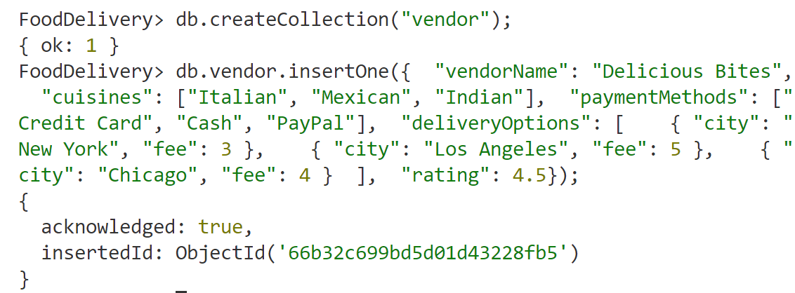

**Code: insert multiple documents in Food Delivery collection.**

|  |
| --- |
| db.vendors.insertMany([ { "vendorName": "Delicious Bites", "cuisines": ["Italian", "Mexican", "Indian"], "paymentMethods": ["Credit Card", "Cash", "PayPal"], "deliveryOptions": [ { "city": "New York", "fee": 3 }, { "city": "Los Angeles", "fee": 5 }, { "city": "Chicago", "fee": 4 } ], "rating": 4.5 }, { "vendorName": "Tasty Treats", "cuisines": ["Chinese", "Thai"], "paymentMethods": ["Credit Card", "Bitcoin"], "deliveryOptions": [ { "city": "San Francisco", "fee": 6 }, { "city": "Seattle", "fee": 4 } ], "rating": 4.2 }, { "vendorName": "Yummy Foods", "cuisines": ["Indian", "American"], "paymentMethods": ["Credit Card", "Cash"], "deliveryOptions": [ { "city": "Boston", "fee": 5 }, { "city": "Miami", "fee": 7 } ], "rating": 4.7 }, { "vendorName": "Healthy Eats", "cuisines": ["Vegan", "Organic"], "paymentMethods": ["Credit Card", "Cash", "Apple Pay"], "deliveryOptions": [ { "city": "Portland", "fee": 4 }, { "city": "Denver", "fee": 5 } ], "rating": 4.9 }]) |

**OUTPUT:**

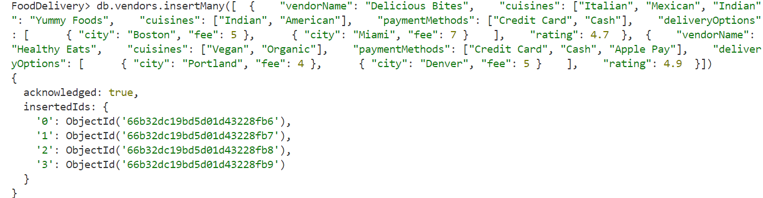

**Execution Steps:**

1. Install MongoDB compass and MongoDB shell
2. Create a new connection in MongoDB Compass
3. Create a new Database eg.)Food Delivery
4. Go to Visual Studio Code
5. Install the MongoDB for VS code extension
6. Click on the MongoDB icon on the navigation pane
7. Right click on the localhost:27017 connection
8. Select Launch MongoDB shell
9. Finally execute the above code.